Simple & Fractional Distillation of Liquid & Liquid Mixture, Respectively

Introduction

General Background
- Distillations are performed to isolate volatile chemicals from non-volatile or less volatile chemicals. In other words, distillation exploits the difference in boiling points of the different liquids to separate them from a mixture. This experiment addresses how distillations (both simple and fractional) can be used to isolate chemicals in pure form. In addition, boiling points and other physical properties can be determined, including refractive index and density of purified materials.
- The apparatus to perform distillation is known as a still. The liquid collected after the
vapors condensed is known as the distillate. The remaining portion left in the distillation pot is called the residue. The chemicals used in this experiment are shown here (Figure 1).
 | A. 2-propanol (isopropanol) | B. Water
 | Figure 1: Structures of the Chemicals Used

Simple/Classical Distillation
- When there is only one volatile liquid, a simple distillation can be used. The temperature that the volatile liquid has in the gas phase will be monitored using a thermometer. This temperature should remain constant and reflect the actual boiling point of the chemical under the atmospheric conditions.  - Tap water is used in this part. The dissolved substances (TDS) are the involatile solutes. | 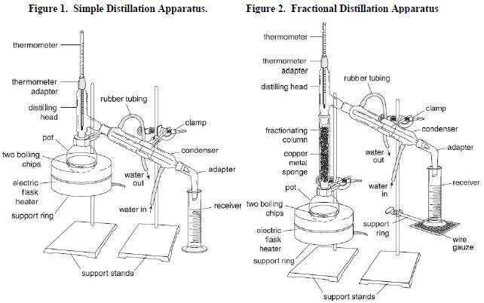
 | Figure 2: Simple Distillation Set-Up

Fractional Distillation
- A fractional distillation is used when separating mixtures of liquids whose boiling points are similar. In the fractional distillation, a mixture of liquids is boiled, and the resulting vapors travel up a glass tube called a “fractionating column” (Vigreux column) to separate. The fractionating column is placed between the flask containing the mixture and the | 
 | Figure 3: Fractional Distillation Set-Up
“Y” adaptor and improves the separation between the liquids being distilled. Fractional distillation leads to a better separation than a simple distillation because the glass beads in the fractionating column provide "theoretical plates" on which the vapors can condense and then re-evaporate, and re-condense, essentially distilling the compound many times over.
- The more volatile liquids will gradually move towards the top of the fractionating column, while higher boiling liquids will stay towards the bottom, giving a better separation between the liquids. The vapor eventually reaches the condenser, where it is cooled and then drips into the collection vessel (receiver).
- A mixture of 2-propanol and water is used in this part. Essentially, it is rubbing alcohol.

General Lab Safety Rules
- Treat all chemicals as toxic
- Ask your instructor whenever you have questions
- No food, no drink, no smoke
- Clothes cover shoulder, shoes cover toes
- Long hair must be tied up
- Clean up glassware and work surface after lab
- Wash hands before you leave
- SDS Information: Isopropanol or 2-propanol (SDS 080), Benzoic Acid (SDS 023)

Experimental

Sample Procurement
- Obtain 1 sample of pure liquid with a non-volatile impurity. It is about 25 mL.
- Obtain 1 sample of a binary mixture of liquids. It is about 40 mL.

Simple Distillation Set-Up
- Measure the mass and volume of the obtained liquid.
- Look at the picture of the simple distillation set-up. Obtain ALL the parts you need from your kit.
- Clear the space by the sink to assemble your parts for the distillation.
- Instead of the heating mantle, you will use a porcelain evaporating dish (wide mouth) filled with sand and a small hot plate.
- Set up the ensemble in the cleared space by the sink such that the heating block is farthest from the sink. Get your set-up inspected by the instructor BEFORE you start.
- The instructions are intentionally NOT step by step. Please use your intuition for the set-up.
- Collect ~20 mL of the distillate. DO NOT allow the still to go dry.
- Instructor will show you the refractive index data collection procedure.

Fractional Distillation Set-Up
- Measure the mass and volume of the obtained liquid.
- Look at the picture of the fractional distillation set-up. Obtain ALL the parts you need from your kit. If you do not have any part, please ask your instructor about it.
- You will do the same procedure as you have done for the simple distillation to set-up. Follow the picture and use your intuition. Get your set-up inspected by the instructor BEFORE you start.
- Instructor will show you the refractive index data collection procedure.

Data Table 1: Simple Distillation Data
Crude Volume (mL) | 24.979 | Crude Mass (g) | 88.594
Boiling Point of Water (ºC) | 100 | Still Head Temperature (ºC) | 99
Distillate Volume (mL) | 15 | Distillate Mass (g) | 19.951

Data Table 2: Fractional Distillation Data
Crude Volume (mL) | 25 | Crude Mass (g) | 19.639
Boiling Point of 2-propanol (ºC) | 82.3 | Boiling Point of Water (ºC) | 100
Still Head Temperature (ºC) | 80 | Column Height (cm) | 10
Distillate Volume (mL) | 22 | Distillate Mass (g) | 17.26

Results & Discussion

Date Table 3: Simple Distillation Results
Volume % Recovery (Yield) | 60.05 | Mass % Recovery (Yield) | 22.52
Distillate Density (g/mL) | 1.3330 | Distillate Refractive Index | 1.56

Date Table 4: Fractional Distillation Results
Volume % Recovery (Yield) | 88 | Mass % Recovery (Yield) | 87.89
Distillate Density (g/mL) | 0.784 | Distillate Refractive Index | 1.29

Conclusions
- Provide an error (besides human error) for this experiment.
I think the biggest error in this experiment was not allowing water to cool our distiller. I think that waiting too long, created a lot of vapors but heated our glass so that there wasn’t any water cooling it to created condensation to measure.
- Provide an explanation (in 5 sentences or less) how the error may affect the recovery.
Not only does the lab take longer but with this error we don’t produce as much measured distilled liquid. We lose a lot due to the vapors not condescending. Without liquid to measure we wont get an accurate measure of how much was distilled, this effects our product recovery and distillate reflective index.
- Did your still head temperature match the literature value of the boiling point of 2-propanol? Discuss (in 5 sentences or less) your answer.
It didn’t match the exact temperature, but it was close. It was off by maybe 2 degrees Celsius.

